
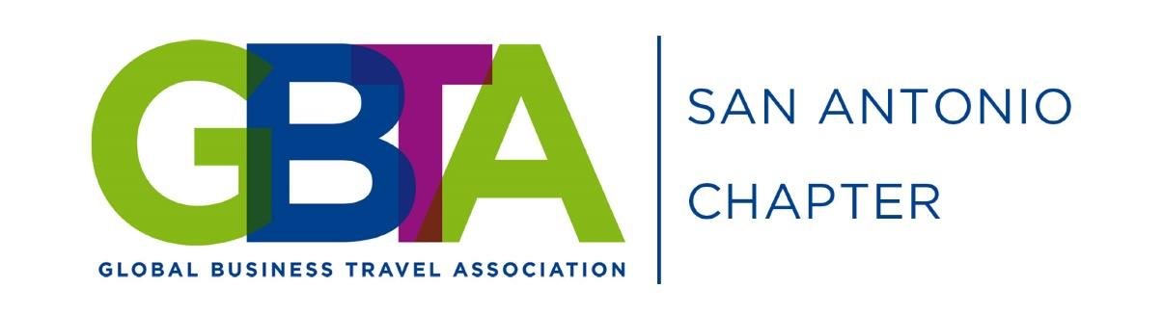
2016 Annual Awards Event

Networking, raffle drawings, hors d'oeuvres, cash bar

Tuesday, December 6, 2016 San Antonio Marriott Northwest
5:30PM – 9:00PM 3233 NW Loop 410, San Antonio, TX 78213
Members and Non-Members = $40 Hotel special rate = $99 + tax
After December 2, Late registration = $50 Contact Melissa Kim: melissa.kim@marriottsanw.com
Registration includes 2 free drink tickets

Register Early! www.sanantoniobta.org

